Solution to the Box Beam Effective Shear Width Problem

Problem
The box beam defined in PGSuper was based on the TxDOT section. The TxDOT section is different than most in that they try to simulate an I-beam profile over the length of the box beam.
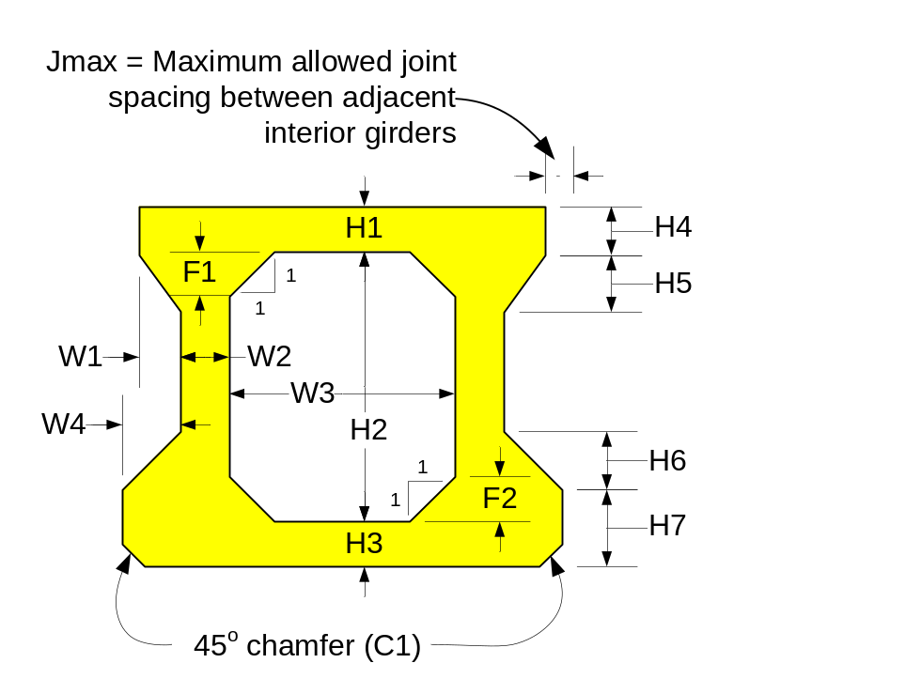
For this configuration, the effective shear width is taken to be W2.

However, the typical box beam has a much smaller shear key.
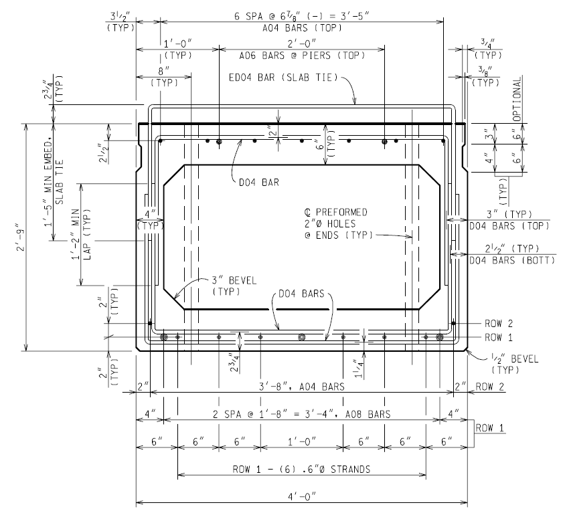

Solution

If the shear key is small and at the same elevation as the top or bottom flange of the box, the effective shear width is taken to be W2 + W4 or W1 + W2 respectively, otherwise it is taken to be W2.

Pseudo Code

Bool bSmallShearKey = (W1 < W2/2 && W2 < W2/2) ? True : False;
Bool bShearKeyAtTop = (H4 < H1 && H7 < H2+H3-F1) ? True : False;
Bool bShearKeyAtBottom = (H7 < H3 && H4 < H1+H2-F2) ? True: False;

If ( bSmallShearKey && bShearKeyAtTop)
{
bv = W2 + W4;
}
Else if (bSmallShearKey && bShearKeyAtBottom )
{
bv = W1 + W2;
}
else
{
bv = W2;
}

